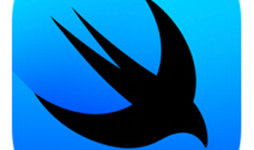

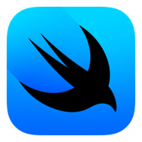

Explore

[**SwiftUI** is a **declarative user interface framework** developed by Apple for building beautiful and dynamic apps across iOS, iPadOS, watchOS, tvOS, visionOS, and macOS using the Swift programming language1](https://en.wikipedia.org/wiki/SwiftUI).

Here are **five free resources** where you can learn SwiftUI:

1. **Apple Developer Documentation - SwiftUI Tutorials**: Explore essential concepts, drawing, animation, app design, and framework integration. [Get hands-on experience while watching your UI unfold in Xcode’s preview](https://en.wikipedia.org/wiki/SwiftUI)[2](https://developer.apple.com/tutorials/swiftui/).
   * [Explore SwiftUI Tutorials](https://developer.apple.com/tutorials/swiftui/)
2. [**100 Days of SwiftUI by Paul Hudson**: Dive into a comprehensive collection of videos, tutorials, tests, and more to effectively learn SwiftUI](https://en.wikipedia.org/wiki/SwiftUI)[3](https://getstream.io/blog/learn-swiftui/).
   * 100 Days of SwiftUI
3. [**Ultimate SwiftUI Cheat Sheet on GitHub**: A beginner’s cheat sheet covering everything you need to know about SwiftUI basics](https://en.wikipedia.org/wiki/SwiftUI)[3](https://getstream.io/blog/learn-swiftui/).
   * SwiftUI Cheat Sheet
4. **SwiftUI Tutorial: Building a Complete Project (Hacking with Swift)**: This tutorial takes you through various SwiftUI functionalities in a single project. [It’s suitable for both newcomers and those familiar with UIKit](https://en.wikipedia.org/wiki/SwiftUI)[4](https://www.hackingwithswift.com/quick-start/swiftui/swiftui-tutorial-building-a-complete-project).
   * [SwiftUI Tutorial: Building a Complete Project](https://www.hackingwithswift.com/quick-start/swiftui/swiftui-tutorial-building-a-complete-project)
5. **SwiftUI by Example (Hacking with Swift)**: Learn hands-on by building a real app project. [Topics include creating menus, composing views, animations, and working with observable objects](https://en.wikipedia.org/wiki/SwiftUI)[5](https://www.hackingwithswift.com/quick-start/swiftui/).
   * [SwiftUI by Example](https://www.hackingwithswift.com/quick-start/swiftui/)

Happy learning! 🚀📱